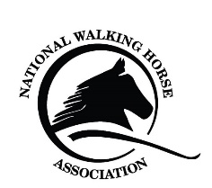
Georgia Jubilee
Regional Championship Show
Bullock County Ag Complex,
Statesboro GA. 30458

Horse’s Name: | Horse’s Registration Number:
Registration Group: | Sex of Horse: Mare Stallion Gelding
Date of Birth of Horse:

Owner’s Name: | NWHA Number:
Phone #: | Owner’s Address:
Email Address:
Owners Classes:

Trainers Name: | NWHA Number:
Phone #: | Owner’s Address:
Email Address:
Trainers Classes:

Rider #3 Name: | NWHA Number:
Phone #: | Owner’s Address:
Email Address:
Rider’s #3 Classes:

Fee | Number of Fees | Total
Preliminary: Pre entry - $20 Post entry $25
Championships: Pre entry $30 Post-entry $35
DQP Fee - $15/day
Office Fee - $15.00/horse
Stall Fee – (w/2 bags shavings) $85.00
Extra Shavings - $8.00/bag
Sponsorship
Grounds Fee - $15.00/horse/day
Camper Fee - $35.00/night
NWHA Membership/Card
Total

Each entry constitutes an agreement that the owners, exhibitors, lessees, trainer, manager, agent coach, rider and the horse is eligible as entered and shall be subject and bound to the bylaws and rules of NWHA and the rules of the show. Furthermore, the above mentioned also accepts the final decision of NWHA on any question arising under said rules, and agree to hold the show, the NWHA, their officials, directors and employees harmless for any action.

Signature of Owner Trainer

Signature of Adult if owner/ Exhibitor is a Minor

